Alpha - Version
Technical Documentation
(Software Technical Documentation)
Project: Chemical Analysis System
Plant: High Chrome Ball Plant
Version: 4.2.0.1
Prepared by: Tsundzukani Nkuna
From Date: 2025/ 05/ 26 To Date: 2025/ 05/ 29

Purpose of Software Technical Documentation
- Explain functionality (how something works)
- Guide implementation (how to build or configure it)
- Support troubleshooting (how to fix issues)
- Enable maintenance (how to update or manage it)

Set Database Connection
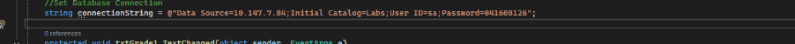
Bind data to the Grid View and Check if Grid View has Data to Export to Excel
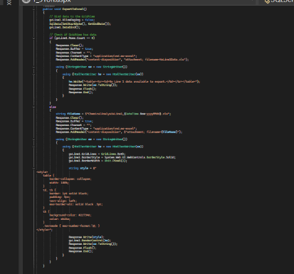
Exported Data to Excell
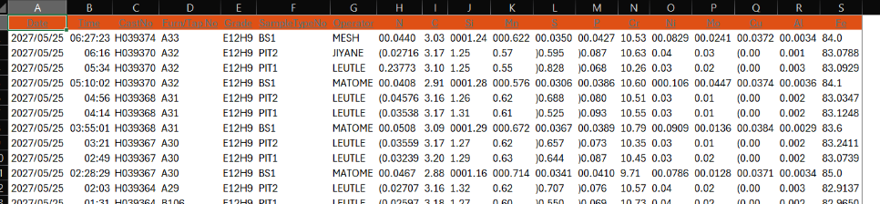
Retrieves Data from Database and bind it to Grid View
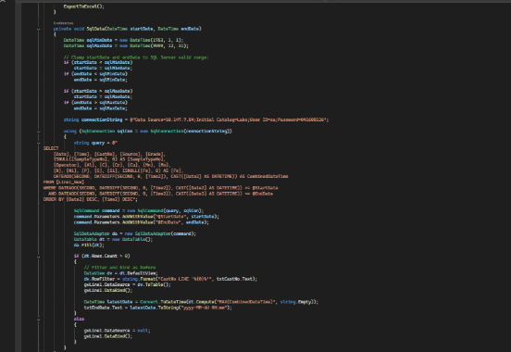
Retrieved Data from Database and Displayed in Grid View
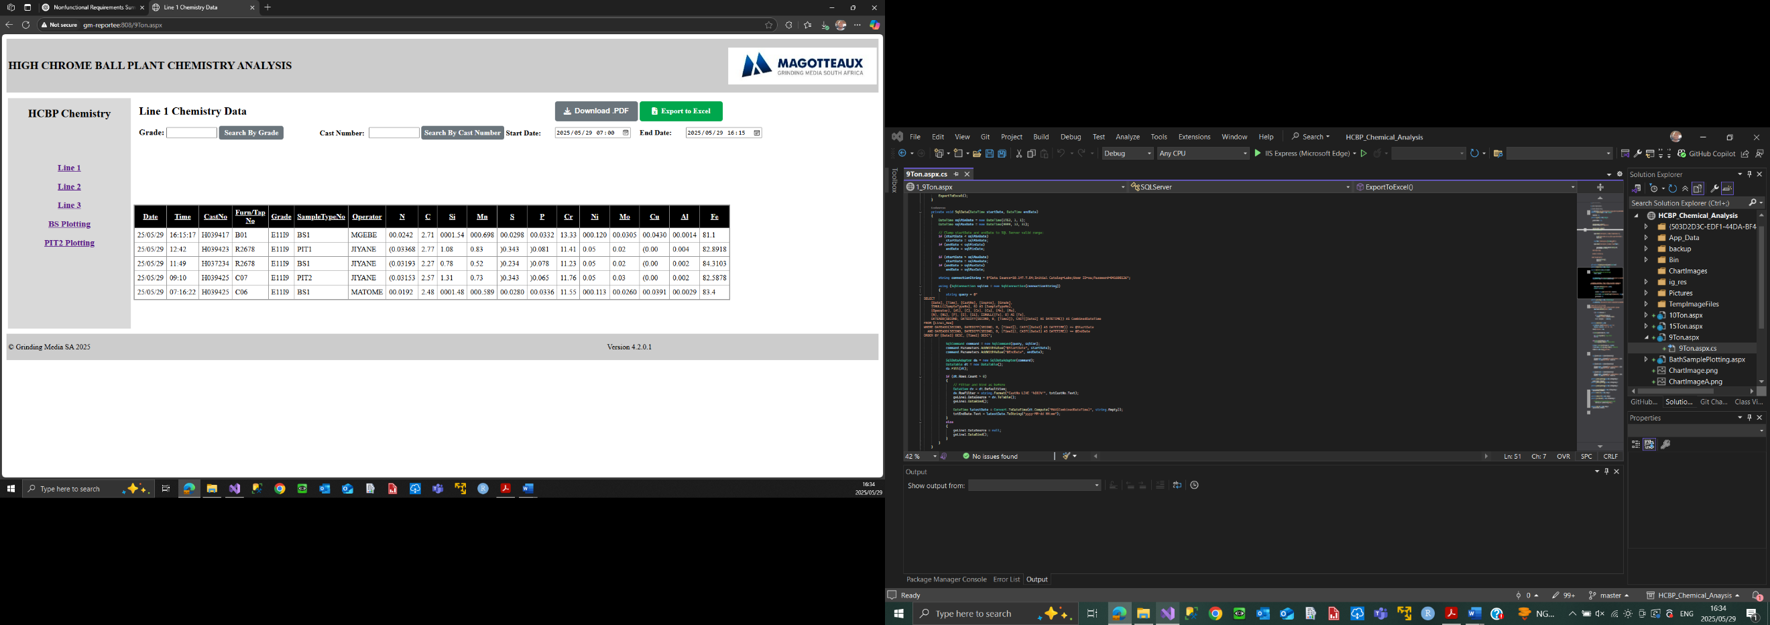
Allow Data to be Displayed From 7 am Today in the Morning until 7 am Tomorrow in the morning Continuously and in Text Date Range Change it executes the Selected Start Date, Time and End Date, Time
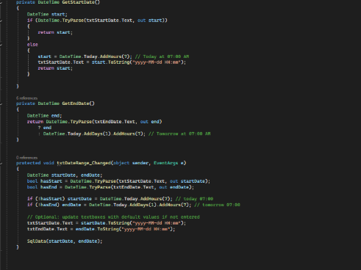

Allow Search by Grade and Bind Data to Grid View As Maximum Grade, Minimum Grade and Aim Grade
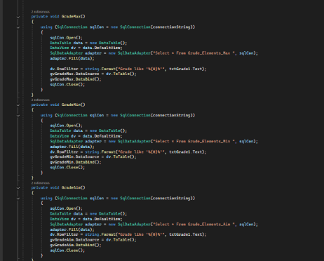
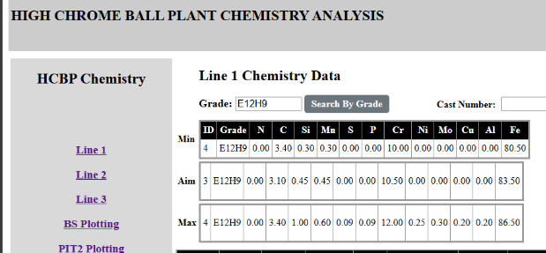
Responsible for Retrieved Data Updates after 15000 Intervals / 15 Seconds
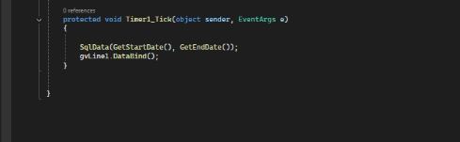

Download Page Content
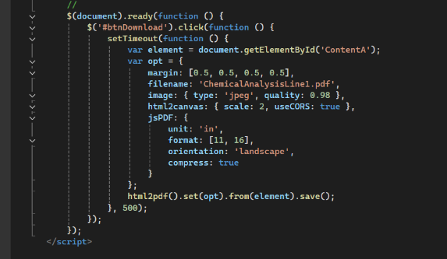
Asp.Net Grid View that is binded to Display Data Executed From SQL Database
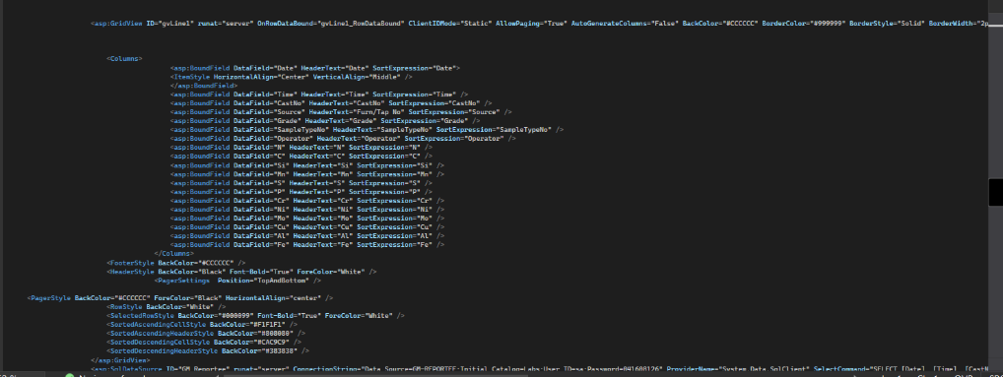

Button Export Click Program
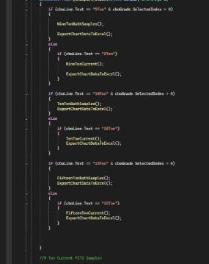
Uses Stored Procedure to Request information From Database and Display as Chart Format
